|  |
| --- |
| **ARENITO MINERALS & CHEMICALS CORPORATION** |
| Comparison: Zeolite and Bentonite Clumping Litter |
| Executive Summary of Results |
|  |
| **LuVerne E.W. Hogg** |
| **5/31/2012** |

|  |
| --- |
|  |

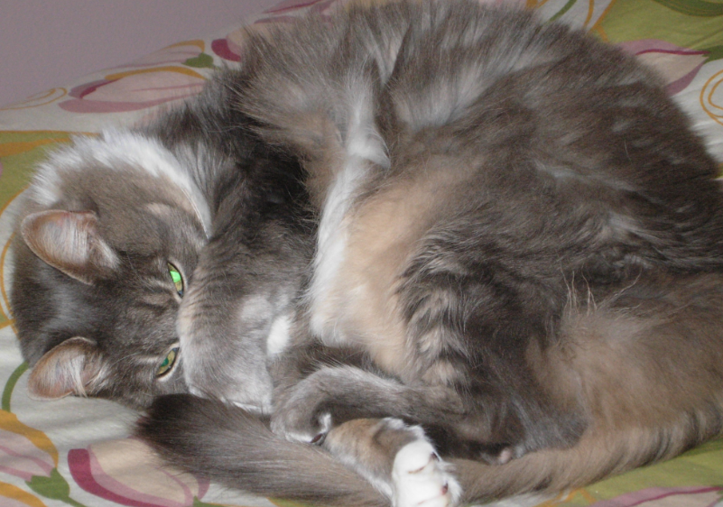

***Table of Contents***

***Introduction 1***

***Test Criteria, Protocol and Procedures 1***

***Summary of Results 2***

***Zeolite Clumping Litter – Trial One 2***

***Bentonite Clumping Litter – Trial Two 2***

***Choice of Clumping Litter – Trial Three 2***

***Mixture of Zeolite and Bentonite Clumping Litters – Trial Four 2***

***Conclusions 3***

***Plate 1 4***

***Plate 2 4***

***Plate 3 5***

***Plate 4 5***

***Plate 5 6***

***Plate 6 6***

***Plate 7 7***

***Introduction 1***

The development of a zeolite clumping litter is a major breakthrough. The clumping cat litter markets are predominately sodium Bentonite. Clumping cat litter accounts for the majority of litter sales in North America. In order to classify the new zeolite clumping litter comparison tests were conducted from March 15, 2012 to May 5, 2012.

***Test Criteria, Protocol and Procedures***

A single, mature house cat, female and spayed, used to using Bentonite clumping litter was the test cat for this study.

A standard cat box, 16” long and 12” wide, was used. The clumps were removed daily (Plate 1), measured for length and width, and weighed (Plate 2). The target for the number of clumps in the test was 50. Anything unusual was noted. The stools were removed daily and discarded. The clumps were contained and retained for examination (Plate 3).

During the first part of the trial the zeolite clumping litter was used. The quantity of zeolite was maintained at three to four inches. Fifty (50) zeolite clumps were collected. The zeolite clumps were removed, weighed, measured, and stored. Further, the clumps were tested for smell and strength.

During the second part of the trial the cat box contents were changed to a sodium bentonite litter. Fifty (50) bentonite clumps were collected. The sodium bentonite clumping litter was a popular big box store product of the USA, packaged in Canada. The bentonite had a reported fragrance added. The quantity of bentonite was maintained at three to four inches as was the zeolite litter. The bentonite clumps were removed, weighed, measured, and stored. Further, the clumps were tested for smell and strength.

The third part of the trial involved providing the choice of two cat boxes, one filled with zeolite clumping litter, the second filled with the bentonite clumping litter. The two boxes were placed side by side for one week, at which time the placement of the boxes was switched for one week. All clumps were removed, weighed, measured, and stored. Further, the clumps were tested for smell and strength.

During the fourth part of the trial a mixture of 50% zeolite clumping litter with 50% bentonite clumping litter was used. Bentonite clumping litter was added to the box until the mixture was 70% bentonite clumping litter and 30% zeolite clumping litter. All clumps were removed, weighed, measured, and stored. Further, the clumps were tested for smell and strength.

***Summary of the Results 2***

***Zeolite Clumping Litter – Trial One***

1. Following a two to 24 hour period, the clumps had no detectible odor six inches from the clumps. If the clump was less than two hours old there was a slight odor.
2. The zeolite clumping litter had minimal dust from filling the box to removing the clumps. The particle size used was a 20x50 mess which is considerably finer than bentonite clumping litter.
3. The zeolite clumps weighed an average of 120 grams each.
4. The average size was 3” x 2”.
5. The color was a whitish tan.
6. The zeolite clumps had a tendency to remain as individual clumps. There was only occasional amalgamation of the zeolite clumps. The mass of any amalgamated zeolite clumps was considerably less than the amalgamated bentonite clumps. No extra effort was required to remove the amalgamated clumps.
7. When stored outside the zeolite clumps maintained their strength and integrity after approximate one week of sunshine, wind and rain (Plate 4).

***Bentonite Clumping Litter – Trial Two***

1. Following a two to 24 hour period, the bentonite clumps had a slight odor six inches from the clumps. If the clump was less than two hours old there was a noticeable odor.
2. The bentonite clumping litter had significant dust from filling the box to removing the clumps.
3. The bentonite clumps weighed an average of 151 grams each.
4. The average size was 31/8” x 23/4”.
5. The color was a brownish gray.
6. A noticeable aspect of the bentonite clumping litter was a tendency for the clumps to meld together making very large clumps. Therefore, removal of the amalgamated clumps was more difficult due to their size and weight.
7. When stored outside the bentonite clumps disintegrated after approximate one week of sunshine, wind and rain (Plate 5).

***Choice of Clumping Litter – Trial Three***

1. During the choice trial the ratio of zeolite clumps to bentonite clumps was five to one (5:1), regardless of the positioning of the boxes.
2. All other attributes of the individual zeolite and bentonite clumps remained the same.

***Mixture of Zeolite and Bentonite Clumping Litters – Trial Four***

1. Trial four was an interesting trial as the characteristics of the zeolite clumping litter and the bentonite clumping litter melded together very nicely with attributes of both the zeolite and the bentonite.
2. The relative positioning was observed to improve the bentonite clumping litter by reducing the size of the clumps, reducing the odor of the clumps, and increasing the durability of the clumps (Plate 6).

***Conclusions 3***

1. The comparison of zeolite clumping litter and bentonite clumping litter has demonstrated the zeolite clumping litter has superior properties as a clumping cat litter.
2. The odor control of the zeolite litter was noticeably improved over bentonite.
3. The fugitive dust in the zeolite product was measurably less than that of the bentonite product.
4. Handling of the clumps for disposal was more easily accomplished.
5. On a pound per pound basis, the zeolite clumping litter provides 20% more volume than bentonite clumping litter (8lb of zeolite litter = 10lb of bentonite litter).
6. The zeolite clumps utilize 20% less material than the bentonite clumps.
7. An average zeolite clump weighs 120 grams. An average bentonite clump weighs 150 grams.
8. The zeolite clumping litter is 40% more effective than the bentonite clumping litter.
9. The result is a positive net benefit of bulk density and absorbency when using zeolite clumping litter.
10. For transitioning from a bentonite clumping litter to a zeolite clumping litter the compatibility is such you can simply begin to add the zeolite litter to any existing bentonite litter until it becomes 100% zeolite clumping litter.
11. The trial concludes the zeolite clumping litter was preferred by the cat over bentonite clumping litter.
12. There was less spillage around the cat box, after cat use, using the finer granulation of the zeolite litter compared to the bentonite litter.
13. There is a substantial environmental reward in utilizing zeolite clumping litter. Less weight and less volume for better results. 40% less energy, less packaging, less disposal. These environmental rewards create exceptional value.
14. An additional positive environmental impact is achieved at landfill disposal sites - because of the natural properties of the zeolite it absorbs and adsorbs toxins, thereby locking up toxins in the landfill.

***4***

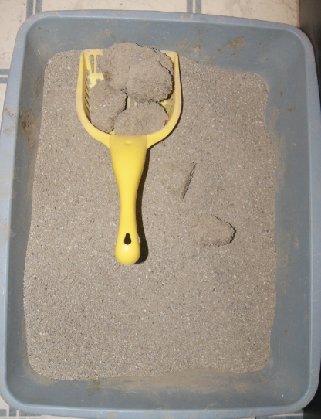

Plate 1

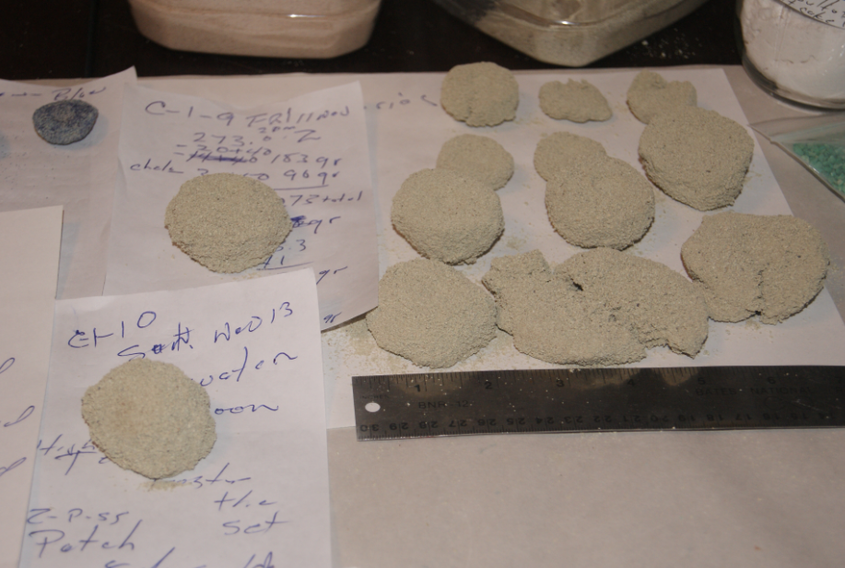

Plate 2

***5***

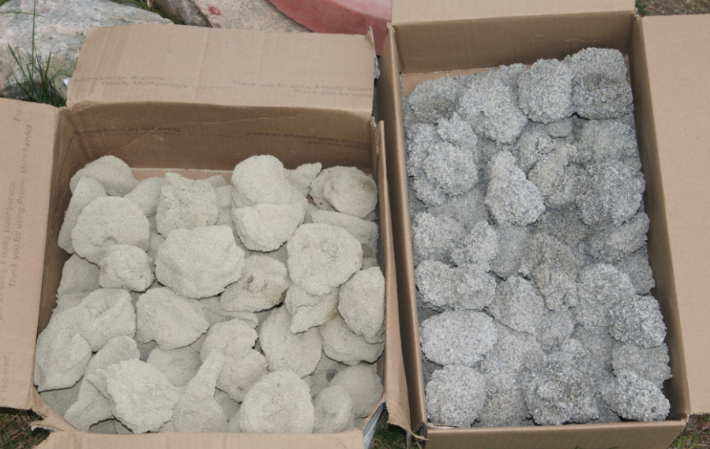

Plate 3

Bentonite Clumps

Zeolite Clumps

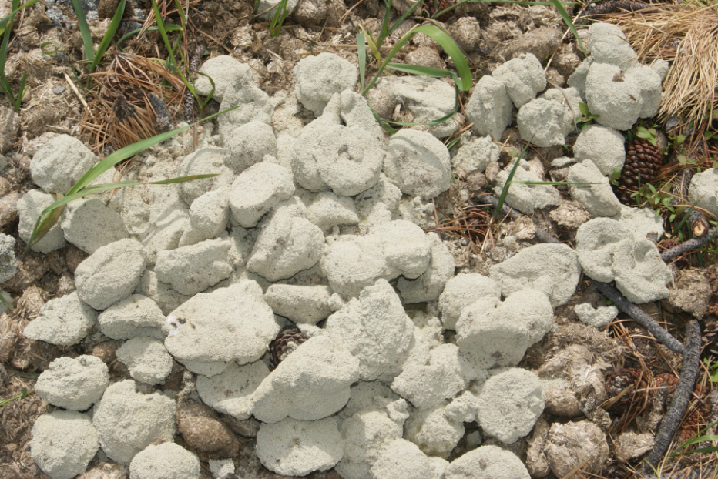

Plate 4

Zeolite Clumps

***6***

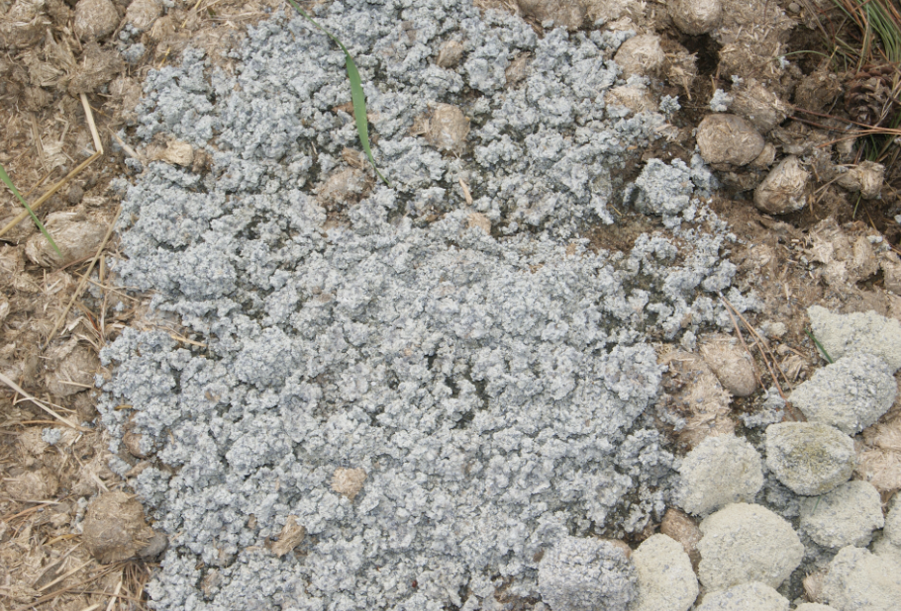

Plate 5

Disintegrated Bentonite Clumps

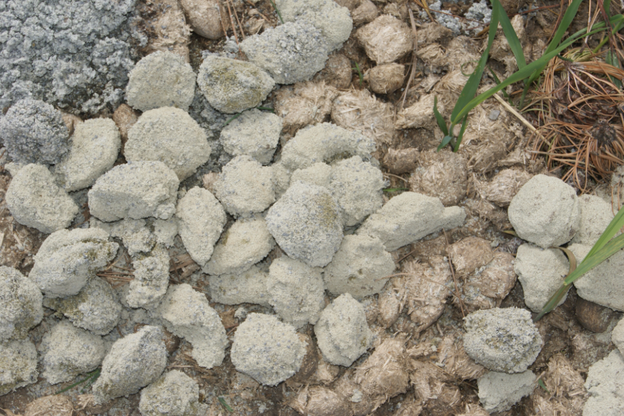

Bentonite/Zeolite Clumps

Plate 6

***7***

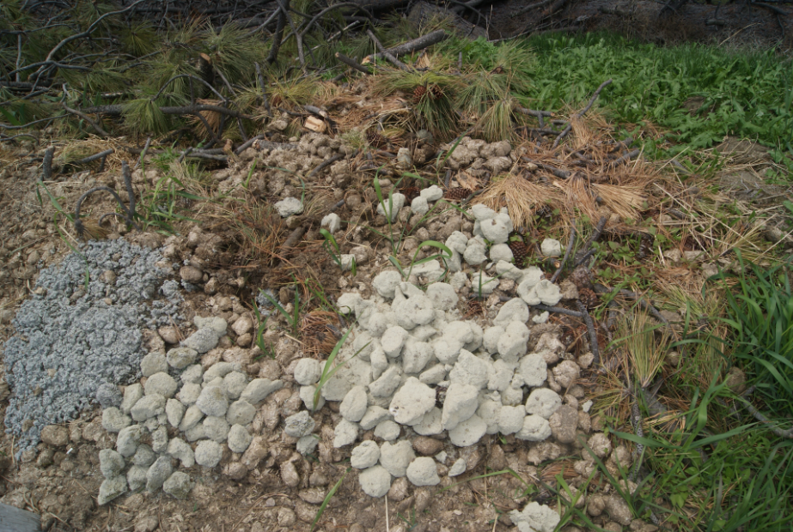

Bentonite/Zeolite Clumps

Bentonite Clumps

Zeolite Clumps

Plate 7